DOCUMENTATION FOR TEST PROJECT

Created by Mustafin Kamil.

2020.

**Contents**

**1. Beginning 3**

**2. First start 4**

**3. Main window 6**

**4. Manager status 12**

**5. Check out of cart 15**

**6. Errors messages 16**

1. Beginning

To open this project you must to:

1. Download project (forSalesForces folder) from github   
   <https://github.com/sOlnblshkO/forSalesForcesIntership>
2. Make sure that you have installed java on your PC.
3. Open folder forSalesForces\dist and start file forSalesForces.jar

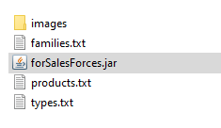

1. Don’t delete any files!!!
2. First start

Then you open forSalesForces.jar you can see a start window.

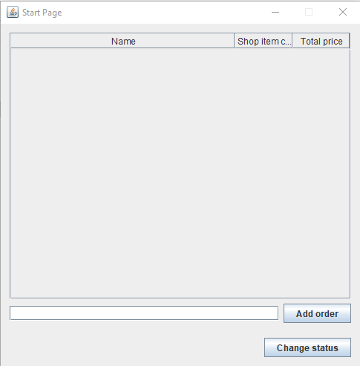

Here you can see main table, small text area, “Add order” and “Change status” buttons.

Main table contains three columns: name of order (account), shop item count, total price. Name of order its name of order (or account, I think they are not different). Shop item its count of different items in cart. Total price its summary of all items, which you added to cart before.

Small text area need to write the name of order (account).



“Add order” button need to add order to main table. At first, you need to write the name in small text area and click button add order and after this in main table will added new row and small text area will be cleared.

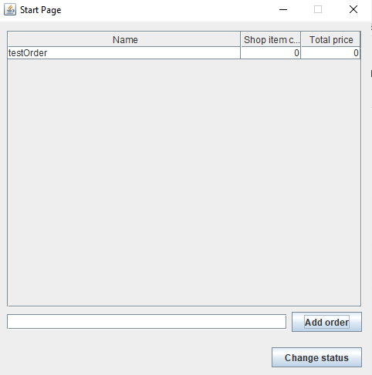

“Change status” button need to activate or deactivate manager status, but about this we will talk latter.

1. Main window

If you want to open the next window, you need to double click some order on main table, which you created before. You will open the main window. It look like this.

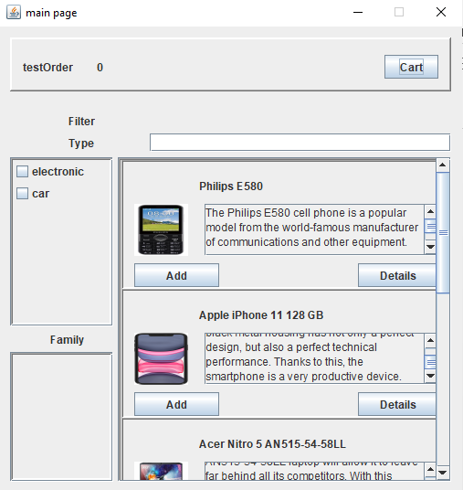

Here you can see the next things: top panel, filter by type, filter by family, search text area, panel with products.

Top panel contains the name and id of order (account) and “cart” button. If click “cart” button it will open new window, which will contain all items that you added to the cart of order, which you selected, but at start, it will clear.

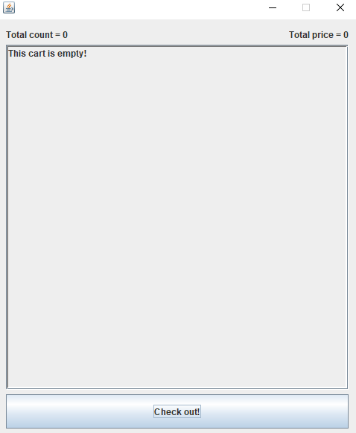

Let`s close it. In filter panels you can see checkboxes. If you want filter items in product panel you must to choose type and (if you need) family filter. For example, let`s choose type car and family DVR items and what will happen.

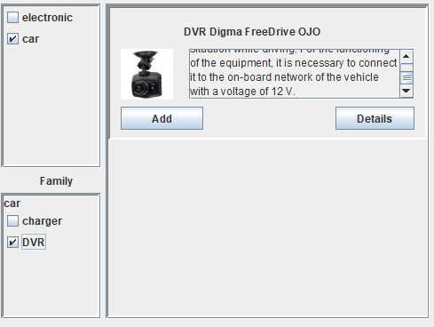

Product panel repainted! In fact, that if we choose only electronic type, family filter will be changed.

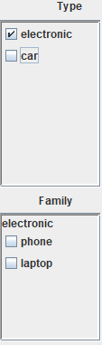

Let`s try to use search text area. Every time than you will write some letter in this text area. Program will search products, which start with letter that you typed.

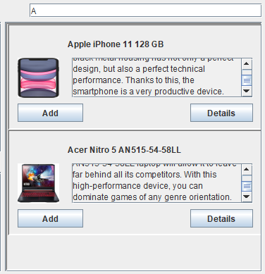

Every product item have the name, image, description, “Add” and “Details” button.

Lets try click to details button. This action will open new smaller window with full description of product.

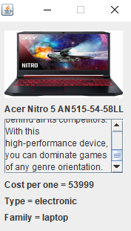

Here we can see image of product, name, description, cost per one, type and family.

If we click to “Add” button, it will be added to our cart. Let’s try to add some products and open our cart to see result.

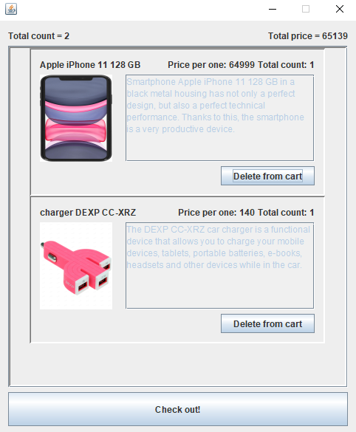

Here we can that total count, total price and panel with products changed.

Total count contain count of different products. Total price it’s a summary of all products. Every item has the name, price per one, total count (if we click “Add” few time, the upper “total count” will not change, but “total count” in product item will change), image, description and “Delete from cart” button. Iphone is too expensive, so I will delete it and show result.

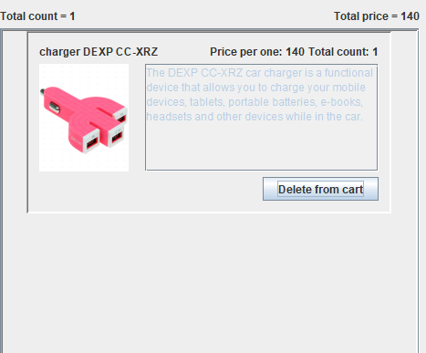

As we can see, upper total count, total price and product panel changed.

1. Manager status

If you want to add new products, you need to change your status. At start page you need to click “Change status”. After clicking, you will see message, which says you “Now you can add products”.

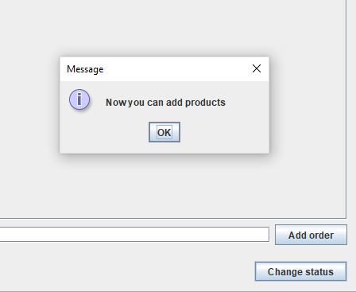

If you want to add some new product, you should to open main window by clicking on some order (account) that you created. And you will see “Create product” button at top panel.



Let’s try to create new product. After clicking on “create product” button, you will see new window. Here you will see some labels and text areas in right side.

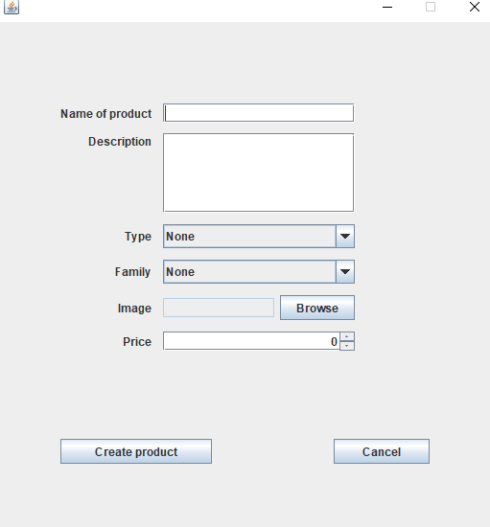

You can easily create new product by filling in all text areas. If product does not has image, there will be words “NO IMAGE” in products panel, so to filling image is not important. Then you filled all text areas, just click “create product” button and it will be added to all products.

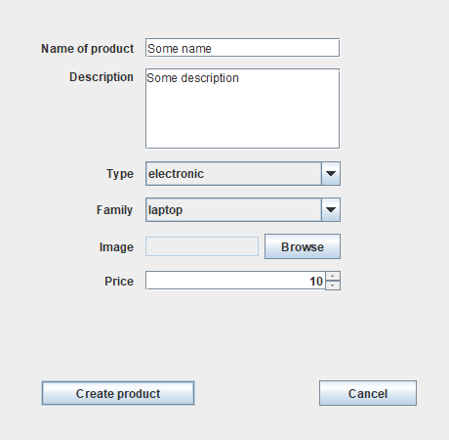

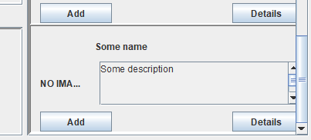

1. Check out of cart

When you added everything that you wanted to the cart, you can check out your cart by clicking on “Check out” in cart window. It will close your cart and return to start page.

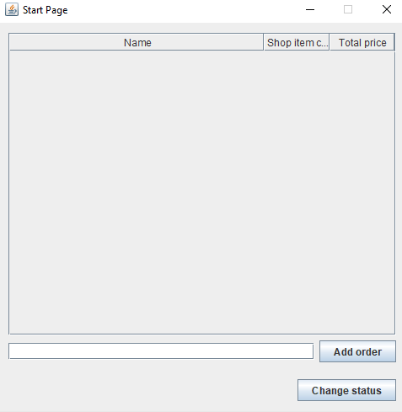

As we can see, we don’t have “testOrder” anymore.

1. Errors messages

- If you trying to add order on start page without writing the name, you will get error “Write name”.

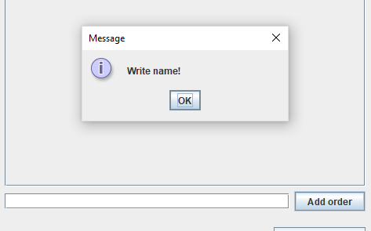

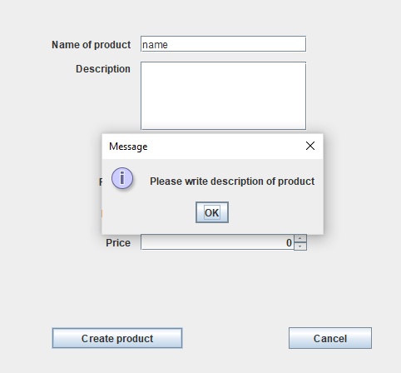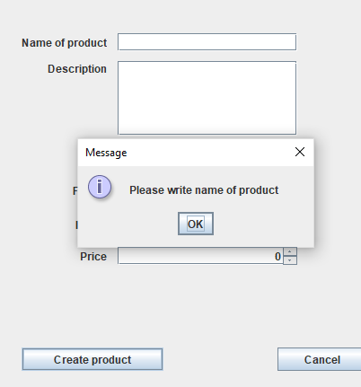- When you trying to create product and didn’t fill some text area, you will get error where you did not fill text area (except image path).

and etc.

- When you will try to delete some product item from cart you will get message and should to choose.

